Name___________________________________________ Date_______________________
Writing the States in Cursive
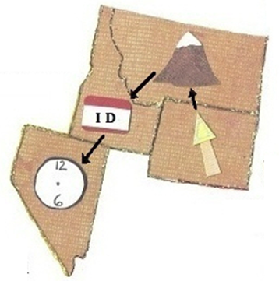 | WY = Wyoming  MT = Montana  ID = Idaho  NV = Nevada
