Name___________________________________________ Date_______________________
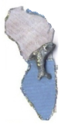
Learning to Print the 50 States
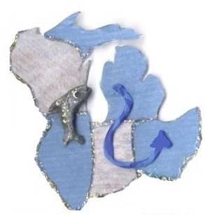 | WI = Wisconsin  IL = Illinois  MI = Michigan  IN = Indiana  OH = Ohio
