Name___________________________________________ Date_______________________
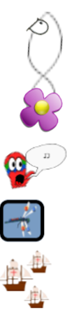
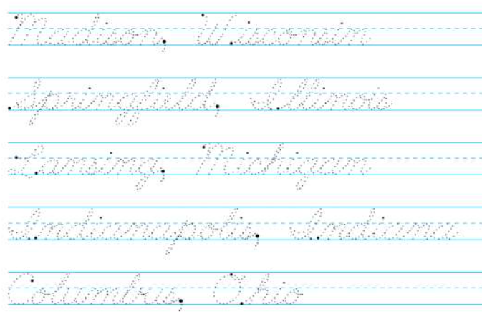
Writing the Capitals in Cursive
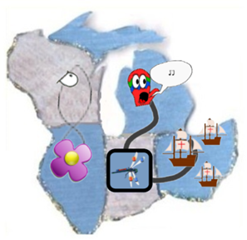 | 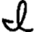  WI = Madison, Wisconsin  IL = Springfield, llinois  MI = Lansing, Michigan  IN = ndianapolis, ndiana  OH = Columbus, Ohio

