Name___________________________________________ Date_______________________
Writing the Capitals in Cursive
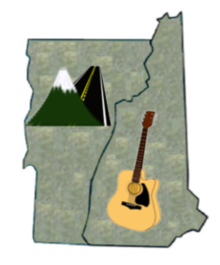 | VT = Montpelier, Vermont  NH = Concord, New Hampshire

