Name___________________________________________ Date_______________________
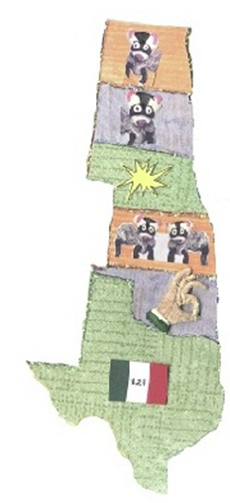
Writing the 50 States in Cursive
ND = North Dakota
SD = South Dakota
NE = Nebraska
KS = Kansas
OK = Oklahoma
TX = Texas
