Name___________________________________________ Date_______________________
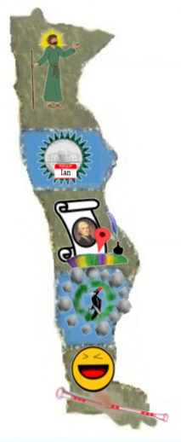
Learning to Print the Capitals
MN = St. Paul, Minnesota
IA = Des Moines, Iowa
MO = Jefferson City, Missouri
AR = Little Rock, Arkansas
LA = Baton Rouge, Louisiana

