Name___________________________________________ Date_______________________
Learning to Print the Capitals
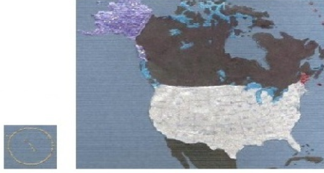 | ME = Augusta, Maine  AK = Juneau, Alaska  HI = Honolulu, Hawaii
