Name___________________________________________ Date_______________________
Learning to Print the 50 States
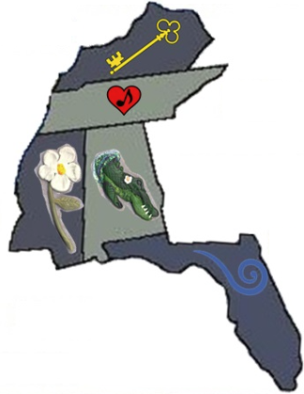 | KY = Kentucky  TN = Tennessee  MS = Mississippi  AL = Alabama  FL = Florida
