Name___________________________________________ Date_______________________
Writing the Capitals in Cursive
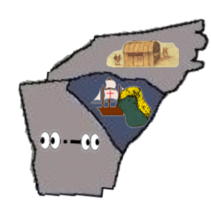 | NC = Raleigh, North Carolina  SC = Columbia, South Carolina  GA = Atlanta, Georgia
