Name___________________________________________ Date_______________________
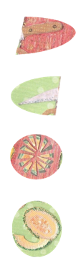
Writing the States in Cursive
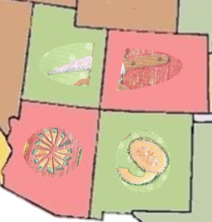 | CO = Colorado  UT = Utah  AZ = Arizona  NM = New Mexico
